
BIT3208: ADVANCED WEB DESIGN AND DEVELOPMENT
MITCHELLE JUMA
BBIT/2024/74591
BACHELOR OF BUSINESS AND IT
UNIT CODE: BIT3208
ADVANCED WEB DESIGN AND DEVELOPMENT
NYORO MICHAEL
YEAR 3 SEMESTER 2
WIGSSTORE_
Technologies used- PHP& MySQL, HTML, XAMPP, GITHUB, CSS, JAVASCRIPT

https://github.com/alexis3-dot/ecommerce_project-wig-store

TABLE OF CONTENTS
Contents
Required evidences 5
1 WEEK 1 : 5
Fig 1: Installation of XAMPP/WAMP/ 5
. 5
Fig 2: Apache and MySQL Running 6
Fig 3: Localhost Test Page 7
Fig 4: Hello World Test 8
Fig 5: Database Connection Test 8
STUDENT REFLECTION 9
WEEK 2 10
Fig 1: Hand-drawn Wireframe (Login/Homepage) 10
10
Fig 2: Dashboard Layout Design 11
Fig 3: Mobile View Mockup 12
Fig 4: Color Theme and Navigation Structure 13
Fig 5: GUI Prototype in Figma/Canva/Draw.io 14
STUDENT REFLECTION 14
WEEK 3 15
• Fig 1: Registration input validation using JavaScript to prevent empty form fields. 15
• Fig 2: Real-time password strength checker script displaying security requirements during customer sign-up. 16
• Fig 3: Configuration layout architecture and dynamic array looping variables implemented within the local workspace. 17
• Fig 4: Database connection initialization script using PDO object mapping to connect with the local MySQL engine. 18
• Fig 5: Dynamic greeting rendering page intercepting POST request data variables and echoing customer input. 19
STUDENT REFLECTION 19
WEEK 4 19
LOG IN FORM Fig 1: Secure Customer Login Gateway Interface Layout 19
FORM VALIDATION Fig 2: Server-Side Form Validation Failing/Error Flag UI Responses 20
PROCESS FORMS USING PHP Fig 3: Conditional Authorization Script Processing in VS Code 21
FOLDER STRUCTURE Fig 4: Modular Application Directory Hierarchy File Explorer Tree 21
DATABASE CONNECTION Fig 5: Active Relational Database Table Index Panels in phpMyAdmin 22
CODE SNIPETTS 23
STUDENT REFLECTION 24
WEEK 5 24
DATABASE SCREENSHOT Fig 1: Complete Relational Schema Map in phpMyAdmin 24
TABLE CREATION SCREENSHOT Fig 2: Database Storage Field Attributes and Column Metric Maps 25
CRUD OPERATION SCREENSHOT Fig 3: Server-Side CRUD Query Implementations for Record Handling 25
DATABASE CODES Fig 4: Session configuration setup, initializing core state variables. 26
SL QUERYCODES Fig5: Session configuration setup initializing core state variables. 27
STUDENT REFLECTION 27
GITHUB VERSION CONTROL 27
Project execution history tracking points registered inside GitHub. 27
Figure 1: Week 1 File on GitHub 28
Figure 2:Week 2 Files on GitHub 28
Figure 3: Week 3 File on GitHub 29
Figure 4: Week 4 File on GitHub 30
Figure 5:Week 5 File on GitHub 30

Required evidences

1 WEEK 1 :

Fig 1: Installation of XAMPP/WAMP/

. 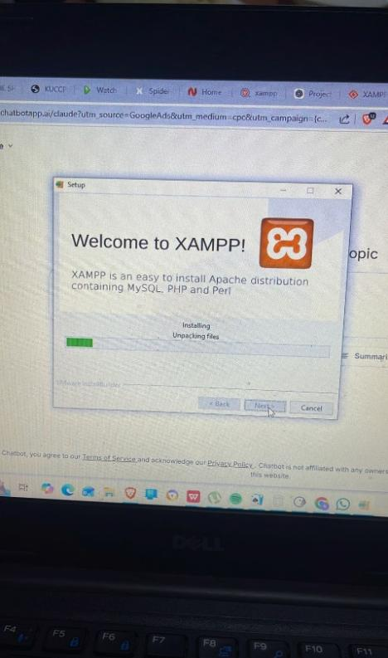
Fig 1 demonstrates the successful installation of the XAMPP software on my computer.

Fig 2: Apache and MySQL Running
Fig 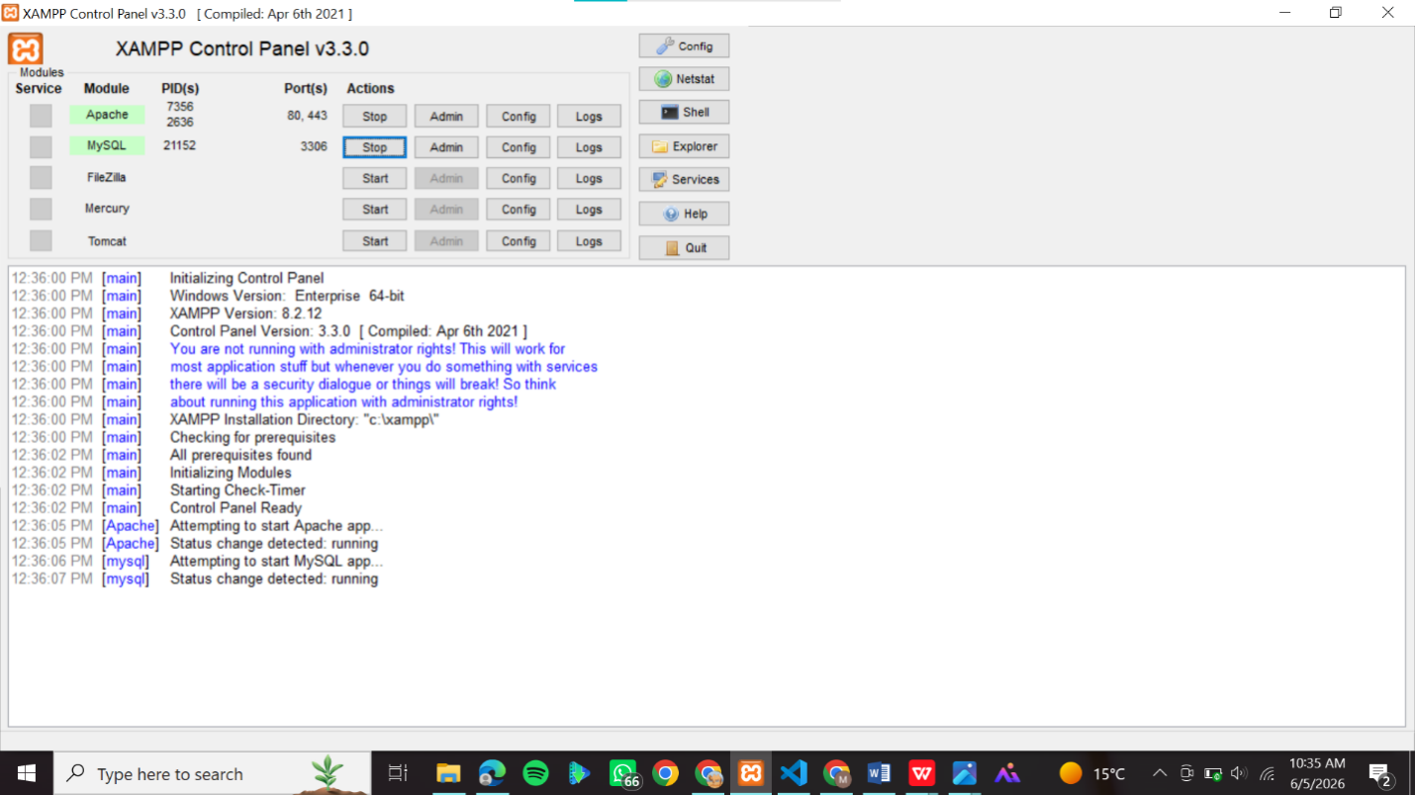2 shows the XAMPP Control Panel with Apache and MySQL services running successfully

Fig 3: Localhost Test Page
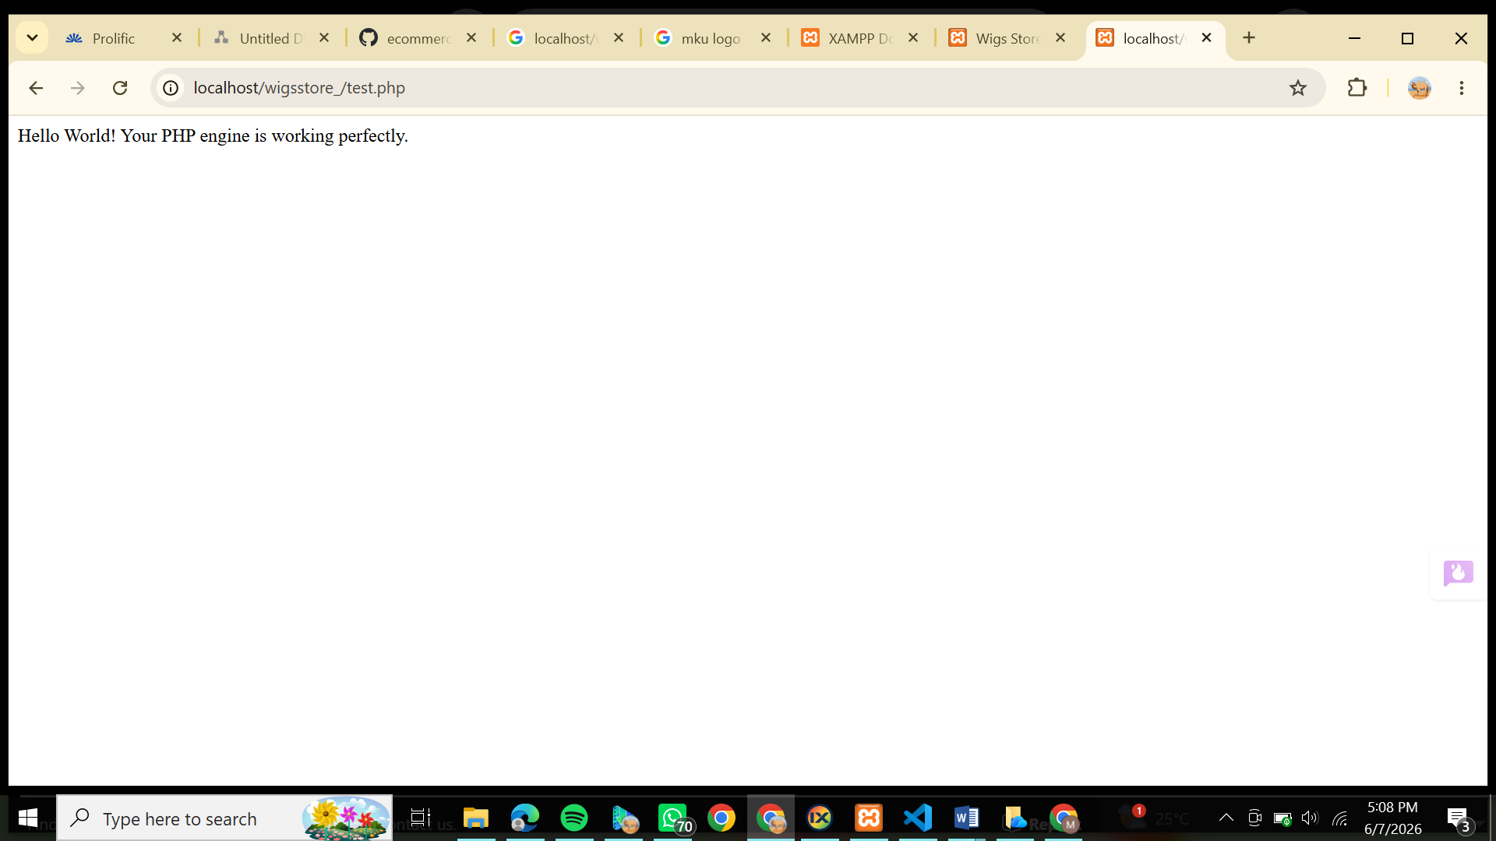Fig 3 displays the localhost dashboard opened in the web browser. Through this step, I learned how browsers communicate with local servers using the loopback address (localhost).

Fig 4: Hello World Test
Fig demonstrates the successful execution of my first PHP script. I learned how PHP code is processed and rendered into a webpage

Fig 5: Database Connection Test
Fig 5 shows a successful database connection between PHP and MySQL using PDO.
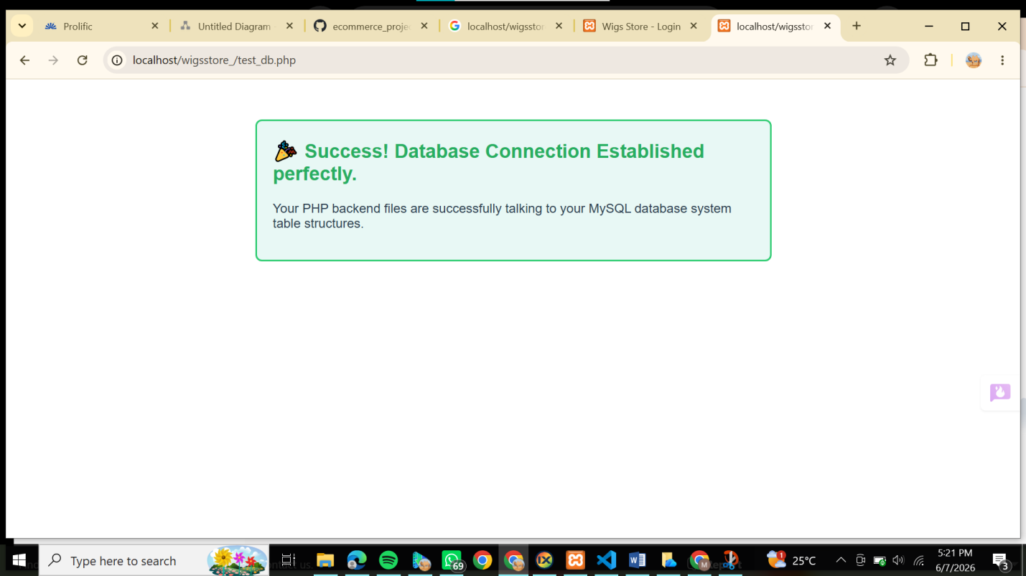

STUDENT REFLECTION
I set up my computer to work as a local server using XAMPP. I enabled Apache and MySQL, so my laptop could run PHP code and handle database storage. I also created a clean project folder structure and set up Git repository tracking. This ensures my files are safely backed up and organized before I write any store code.

WEEK 2

Fig 1: Hand-drawn Wireframe (Login/Homepage)

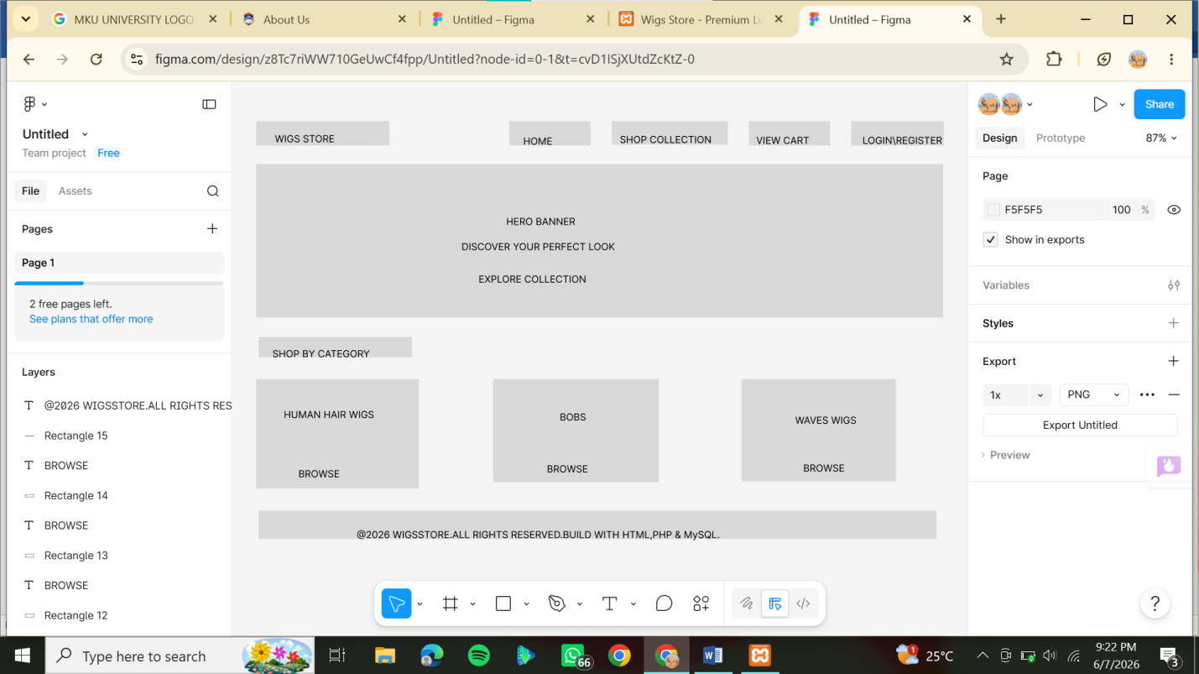
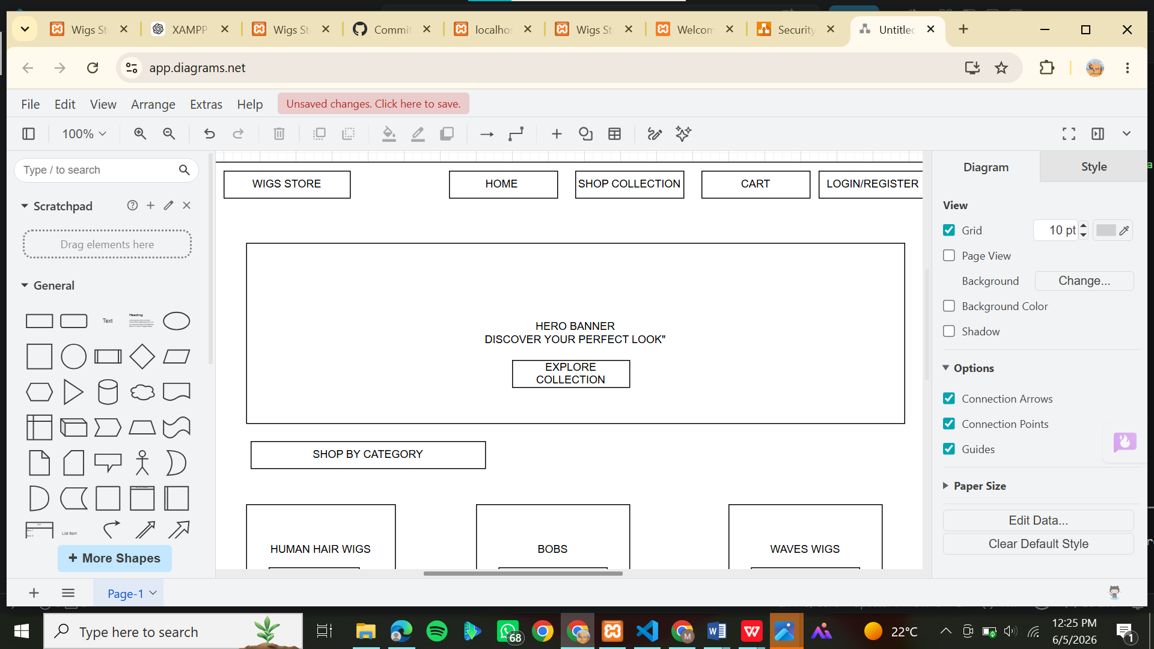Fig 1 shows the hand-drawn wireframe for the homepage and login page. The design was selected to create a simple and organized system layout. User experience was considered by arranging menus and buttons clearly for easy access.

Fig 2: Dashboard layout Design
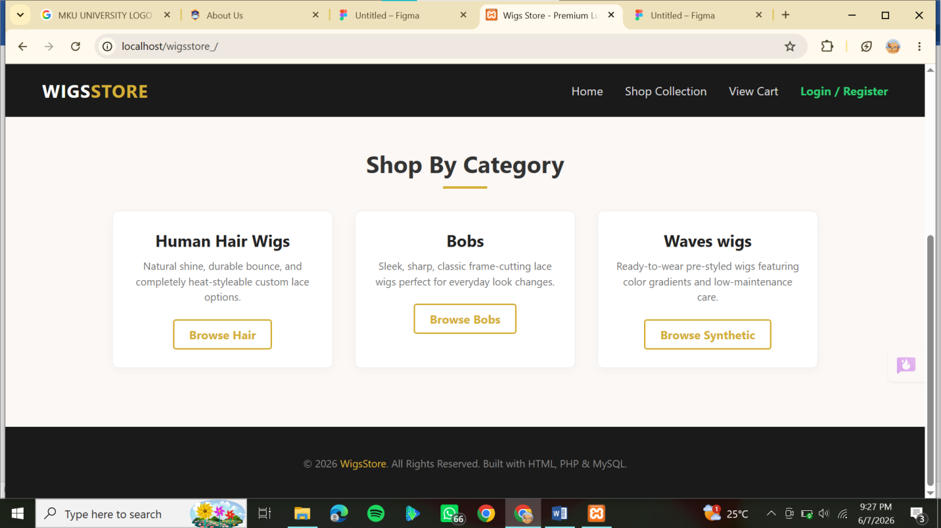Fig 2 presents the dashboard layout design for the admin section. The design was selected to allow easy management of system information. User experience was improved through a clean and well-arranged dashboard structure.

Fig 3: Mobile View Mockup
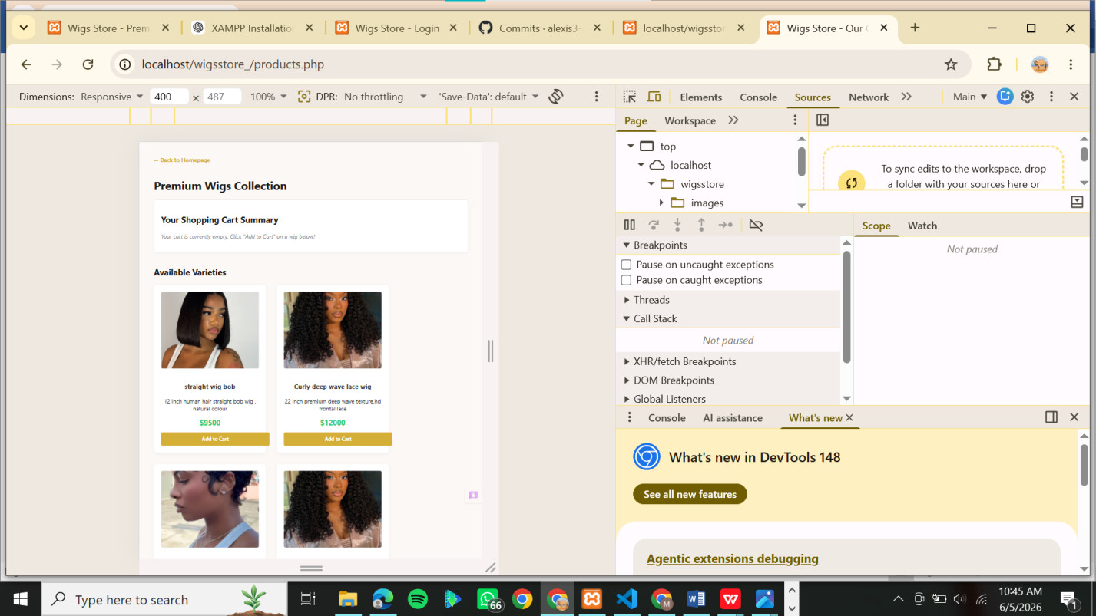Fig 3 shows the mobile-responsive mockup of the system. The design was selected to ensure accessibility on mobile devices. User experience was considered by simplifying menus and screen layouts for smaller devices

Fig 4: Color Theme and Navigation Structure
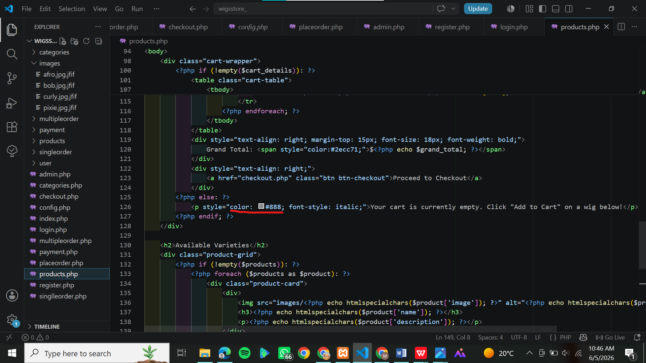Fig 4 displays the selected color theme and navigation structure. The design was selected to create an attractive and readable interface. User experience was considered through the use of clear colors and readable fonts

Fig 5: GUI Prototype in Figma/Canva/Draw.io
Fig 5 shows the final GUI prototype created using design software. The design was selected to administrators. For user experience, I minimize interface clutter to ensure friction-less navigation. The site navigation flowvisualize the final appearance of the system before development

STUDENT REFLECTION
I selected a clean grid layout to optimize product visibility for our target retail customers and system is planned to guide users seamlessly from product browsing straight to an express guest checkout without forced barriers. Figs 1 through 5 demonstrate how these interface decisions translate into functional system designs.

WEEK 3

• Fig 1: Registration input validation using JavaScript to prevent empty form fields.
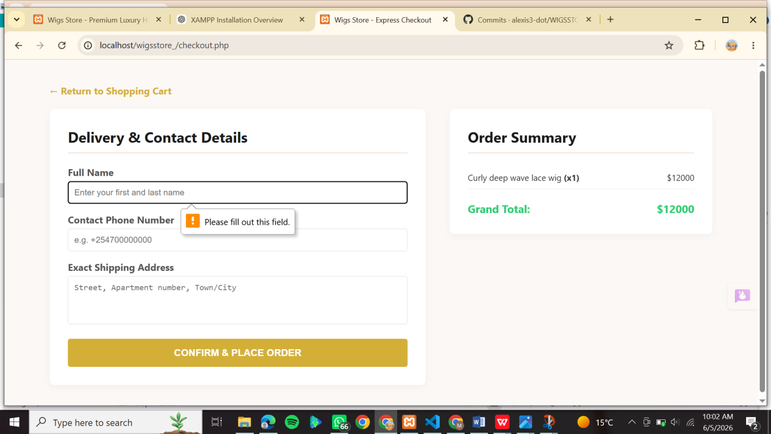

• Fig 2: Real-time password strength checker script displaying security requirements during customer sign-up.
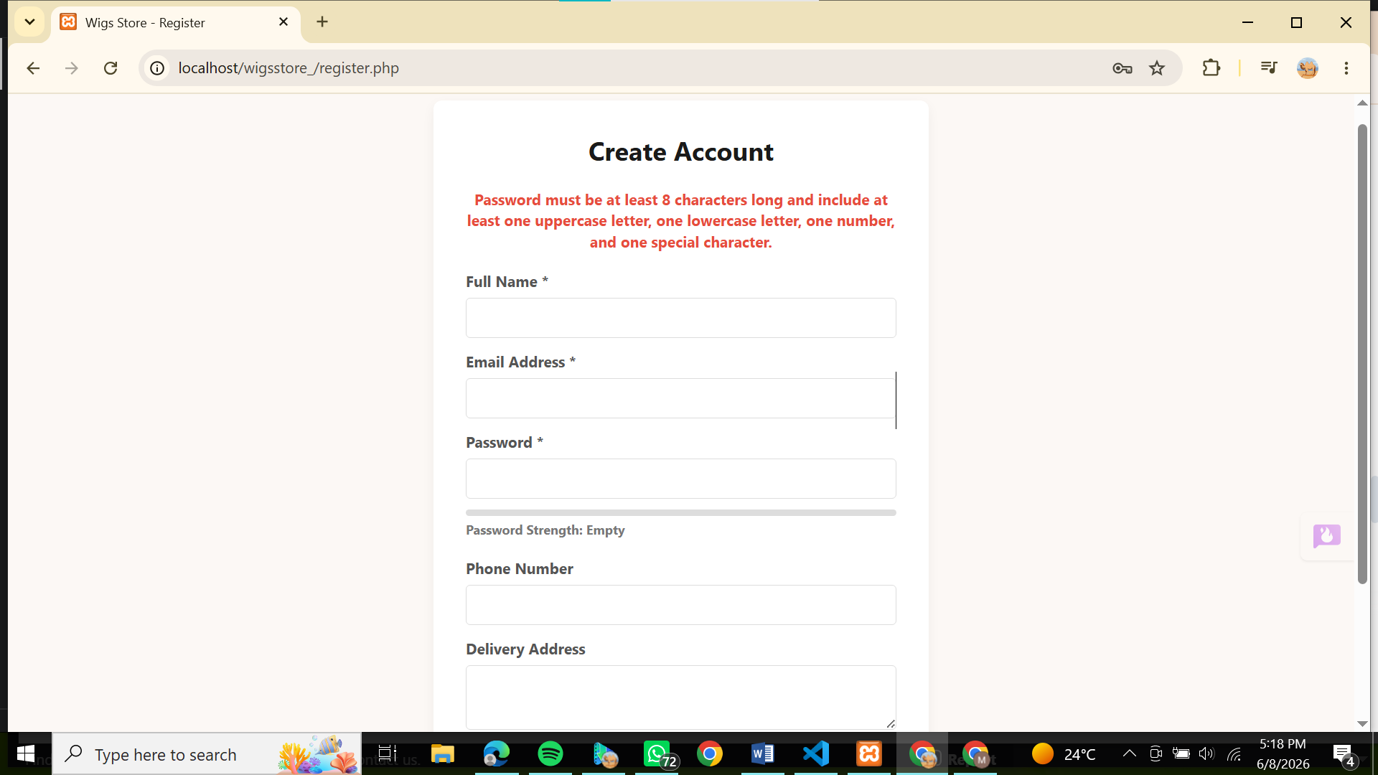Explanation: Fig 2 demonstrates my real-time visual script monitoring the strength of ones password.

• Fig 3: Configuration layout architecture and dynamic array looping variables implemented within the local workspace.
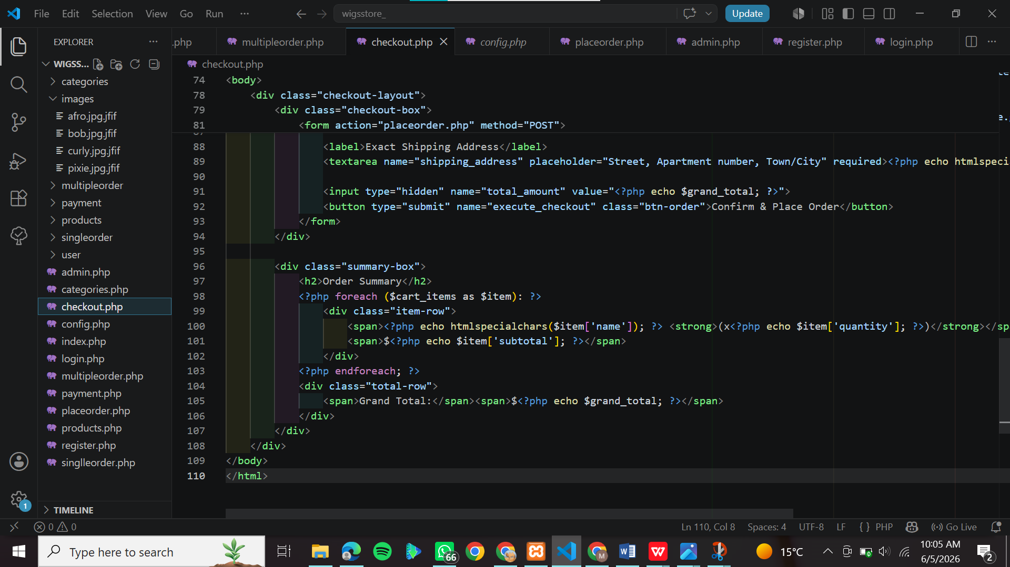Explanation: Fig 3 shows my native server-side scripting structural components open in my code editor window. This demonstrates my implementation of PHP loops, basic arrays, and error tracking flags handling project input data parameters seamlessly.

• Fig 4: Database connection initialization script using PDO object mapping to connect with the local MySQL engine.
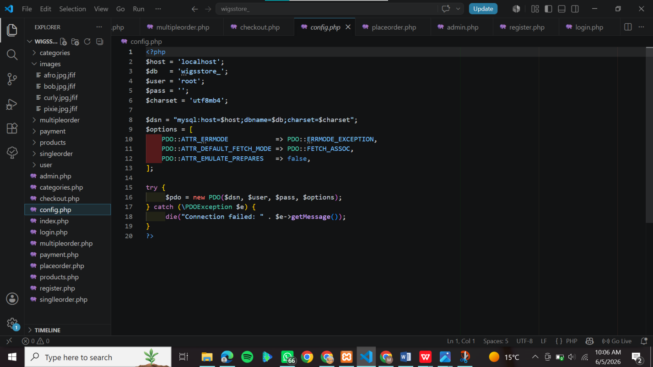Explanation: Fig 4 captures my central backend database connection code. This file uses PHP Data Objects (PDO) to open an active data pipeline straight to my local MySQL engine, enabling data transactions for guest or user sessions.
• Fig 5: Dynamic greeting rendering page intercepting POST request data variables and echoing customer input. 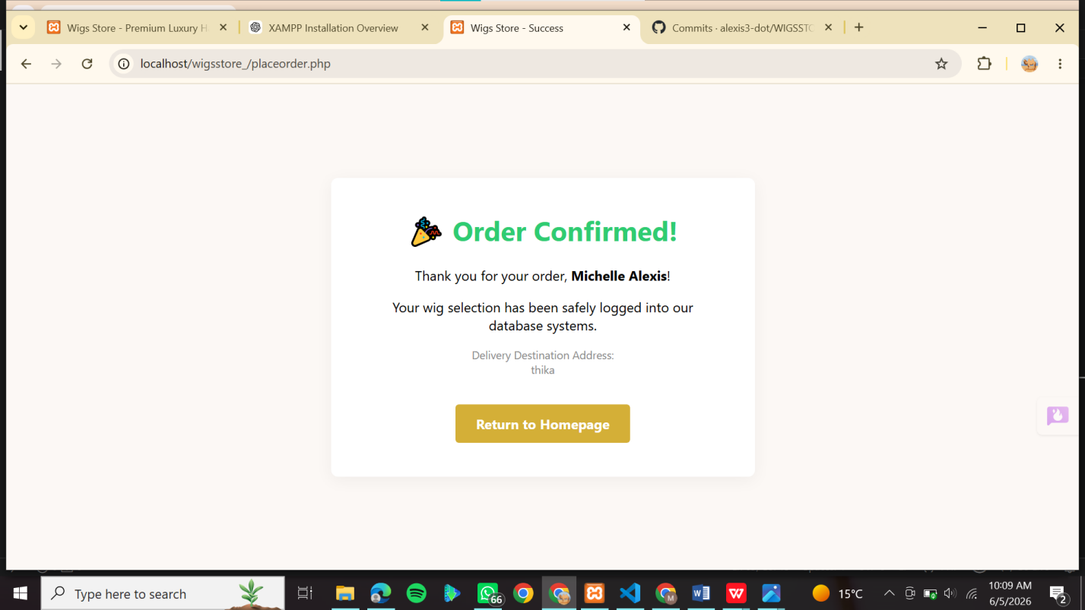
Explanation: Fig 5 demonstrates that server-side scripts successfully catch submitted request metrics and route them into interactive display areas.

STUDENT REFLECTION
I am utilizing JavaScript, PHP, and MySQL to manage data across front-end and backend systems. Client-side validation is crucial because it improves user experience by intercepting errors instantly before data reaches the server. A secure database connection is vital to ensure user and transaction records are permanently and reliably stored. Figs 1 through 5 demonstrate how these interactive frontend layers securely connect with my backend foundations.

WEEK 4

LOG IN FORM Fig 1: Secure Customer Login Gateway Interface Layout
This screenshot displays the frontend user entry interface, highlighting structured username and password input fields designed to capture secure client access credentials.

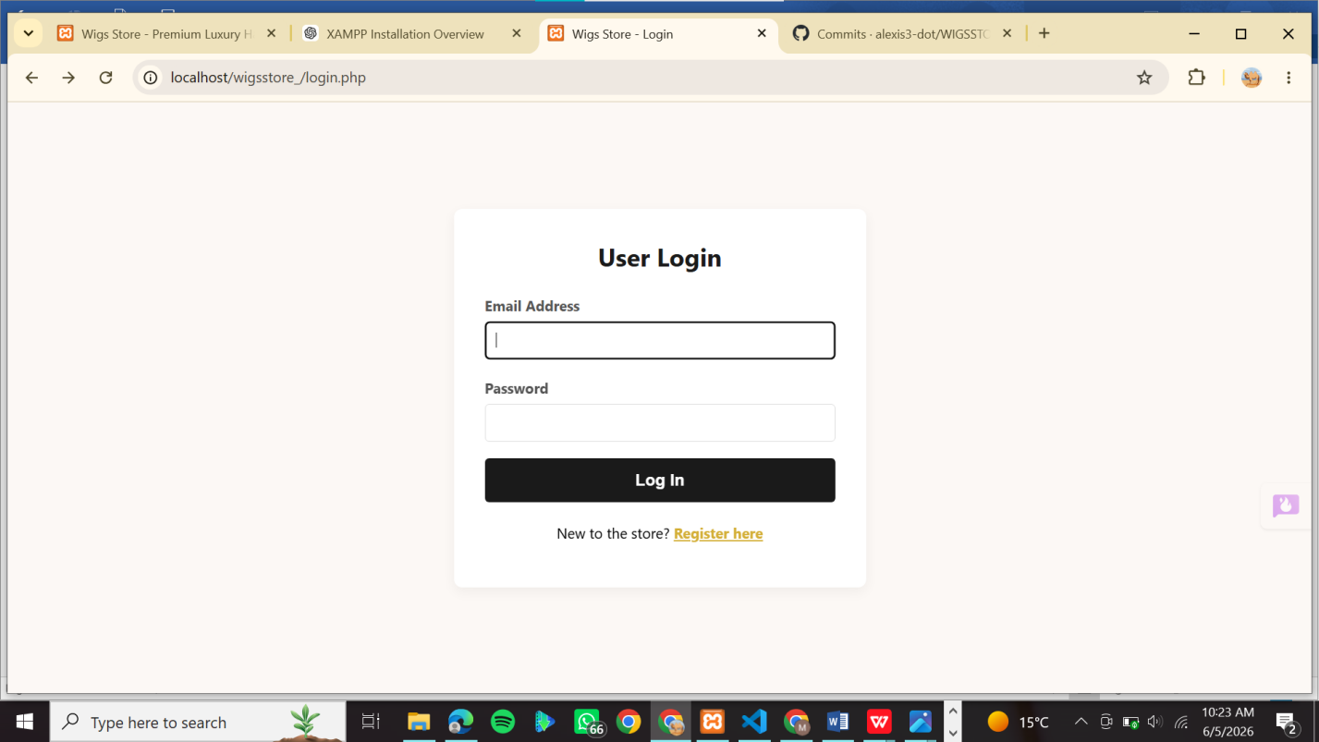

FORM VALIDATION Fig 2: Server-Side Form Validation Failing/Error Flag UI Responses
This screen capture illustrates our internal validation handling scripts catching empty, incomplete, or faulty parameters and displaying an explicit error flag string on screen.

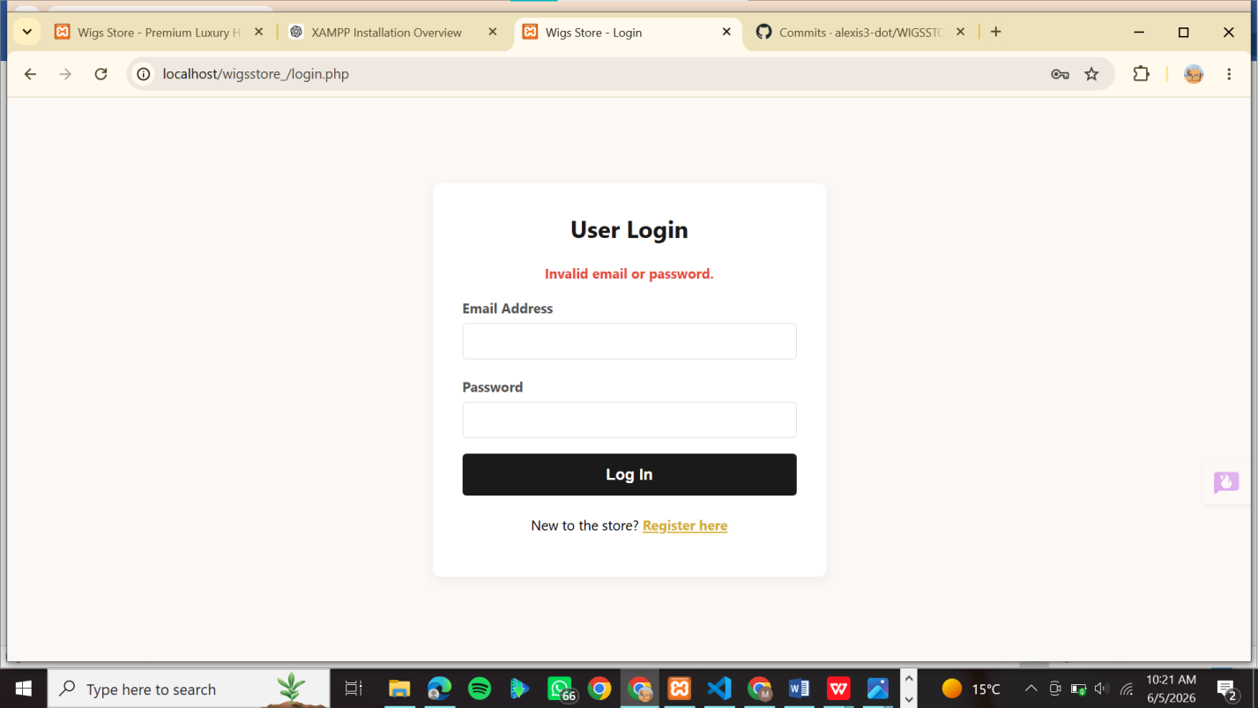

PROCESS FORMS USING PHP Fig 3: Conditional Authorization Script Processing in VS Code
This code block code snippet details the core application flow, utilizing distinct conditional logic layers to process user criteria checks before granting server-side clearance.
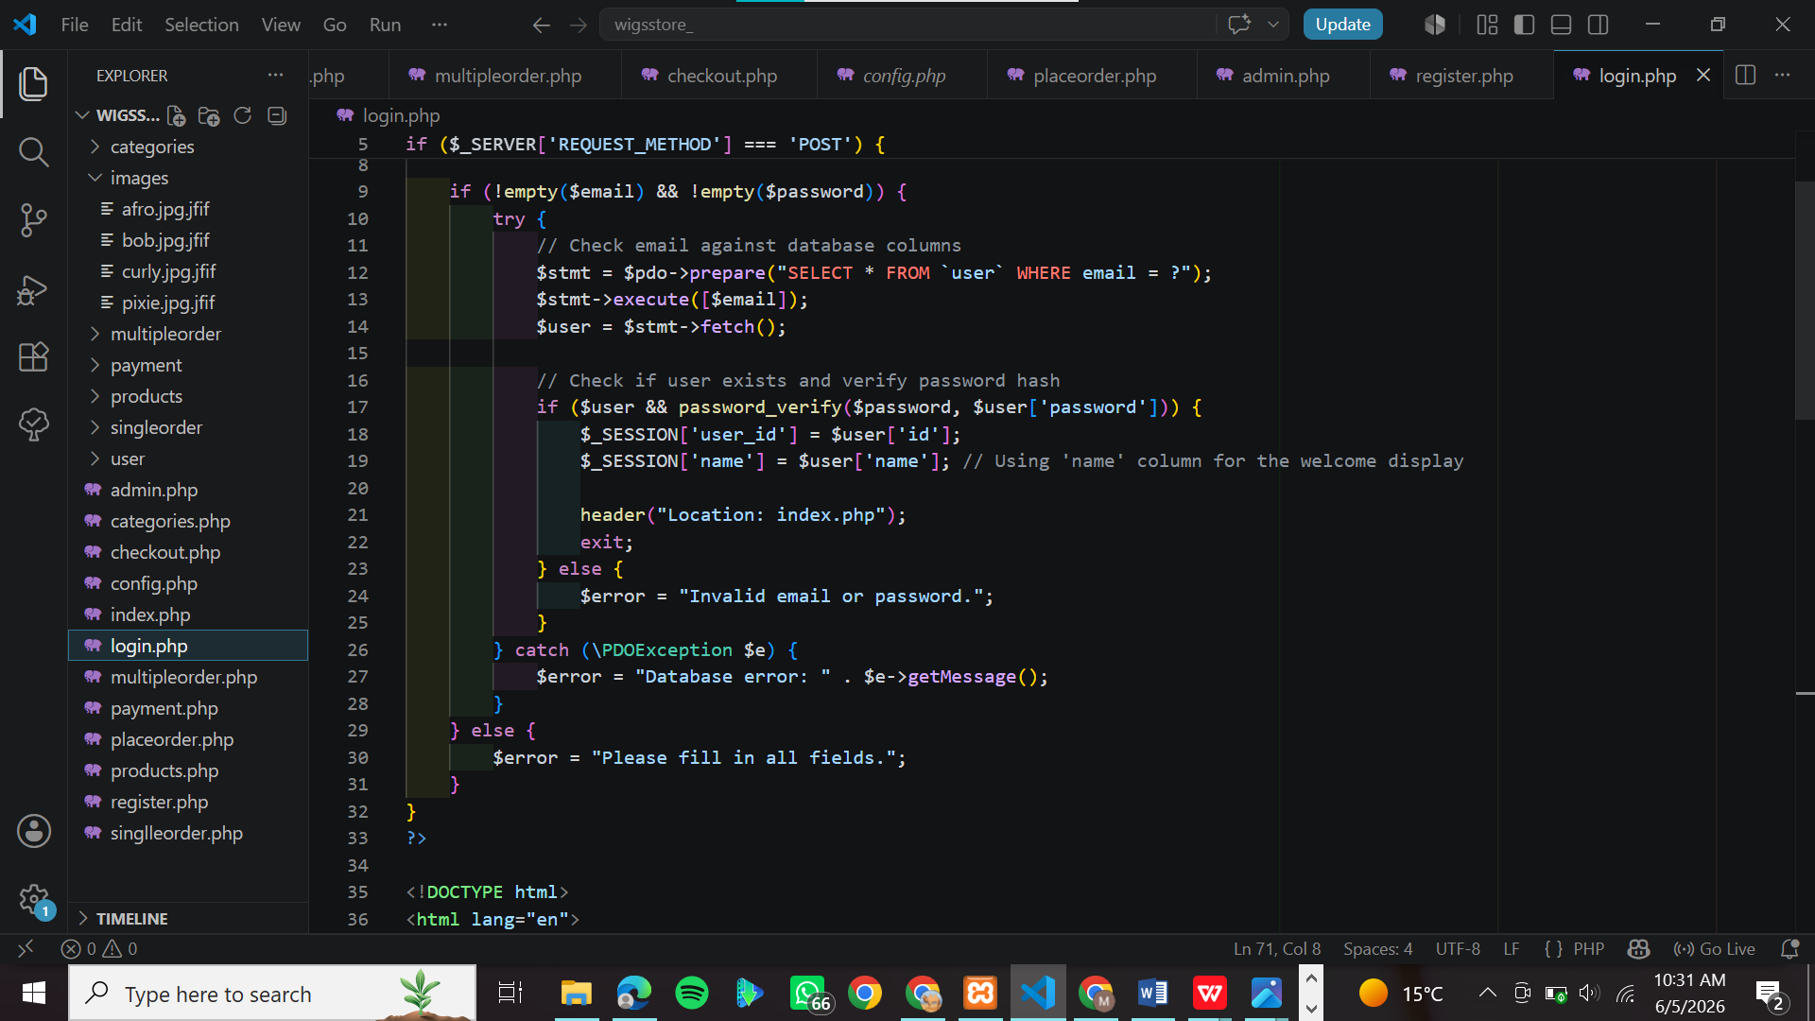

FOLDER STRUCTURESURE Fig 4: Modular Application Directory Hierarchy File Explorer Tree
This view verifies my development environment workspace configuration, displaying properly segmented files and structured directories mapped out inside the code editor interface.

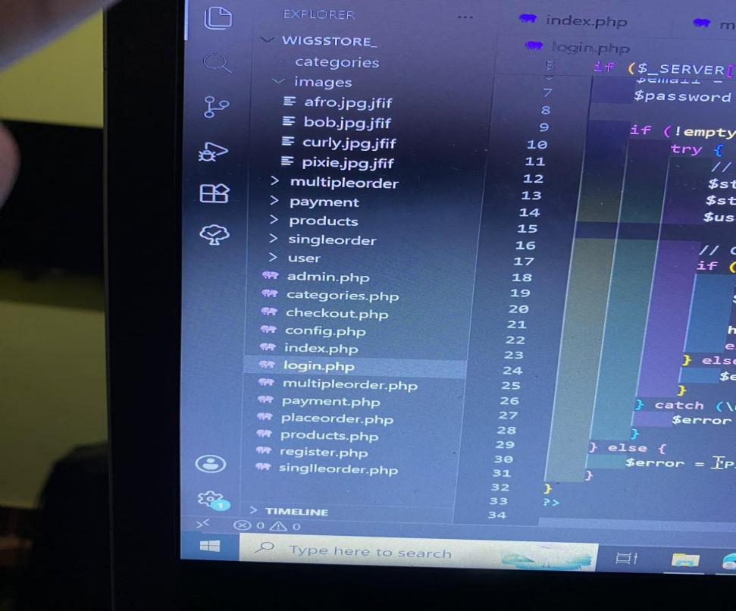

DATABASE CONNECTION Fig 5: Active Relational Database Table Index Panels in phpMyAdmin
This snapshot captures our application database status, verifying that the target local data system architecture is ready to accept persistent transaction records.

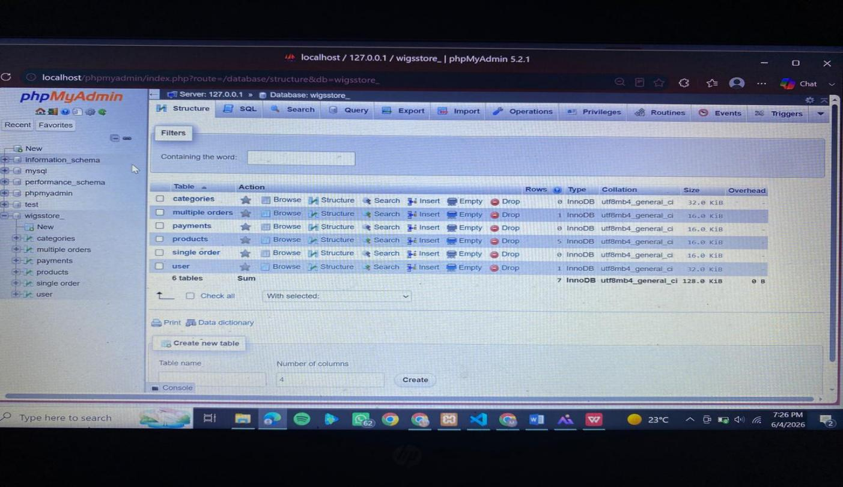

CODE SNIPETTS
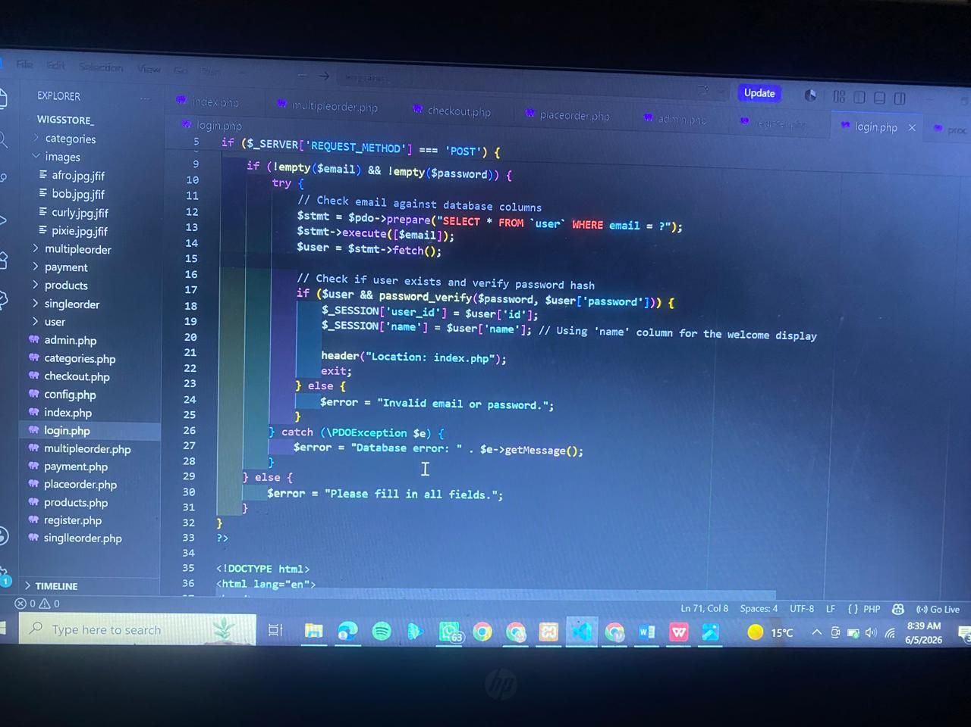

STUDENT REFLECTION
I am using conditional logic and global PHP session state to build a secure authentication flow. I learned how request-response workflows transmit data securely from forms to the backend server. Managing active sessions allows the storefront application to retain user profiles across multiple pages seamlessly. The compiled deliverables across Figures 1 through 5 demonstrate my actual progress in structuring an active, professionally organized system layout.

WEEK 5

DATABASE SCREENSHOT Fig 1: Complete Relational Schema Map in phpMyAdmin
This view displays our active entity layout inside the local storage engine, confirming the configuration of structural tables required by the business store system.

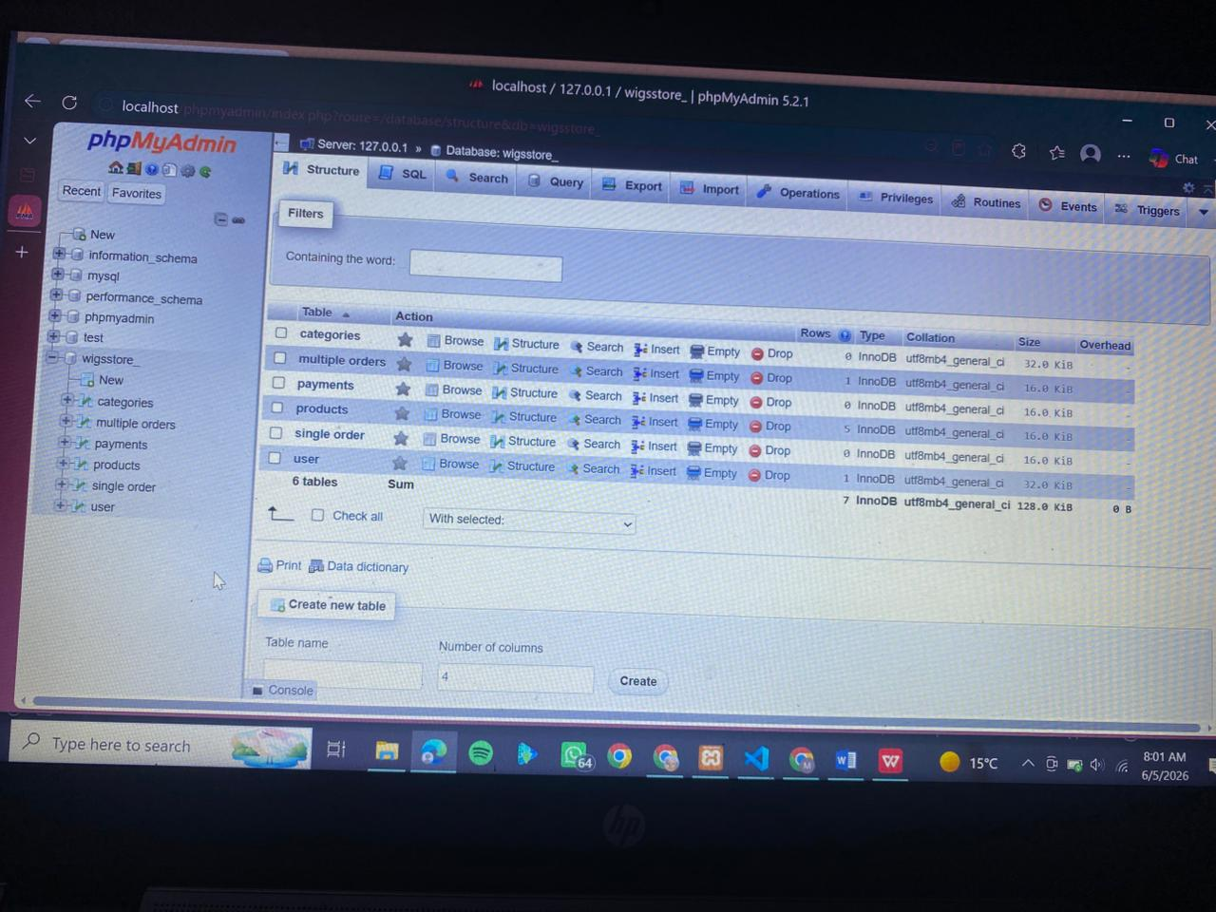

TABLE CREATION SCREENSHOT Fig 2: Database Storage Field Attributes and Column Metric Maps
This screenshot highlights our table constraints, displaying exact column definitions, primary indexing assignments, and data storage type classifications.

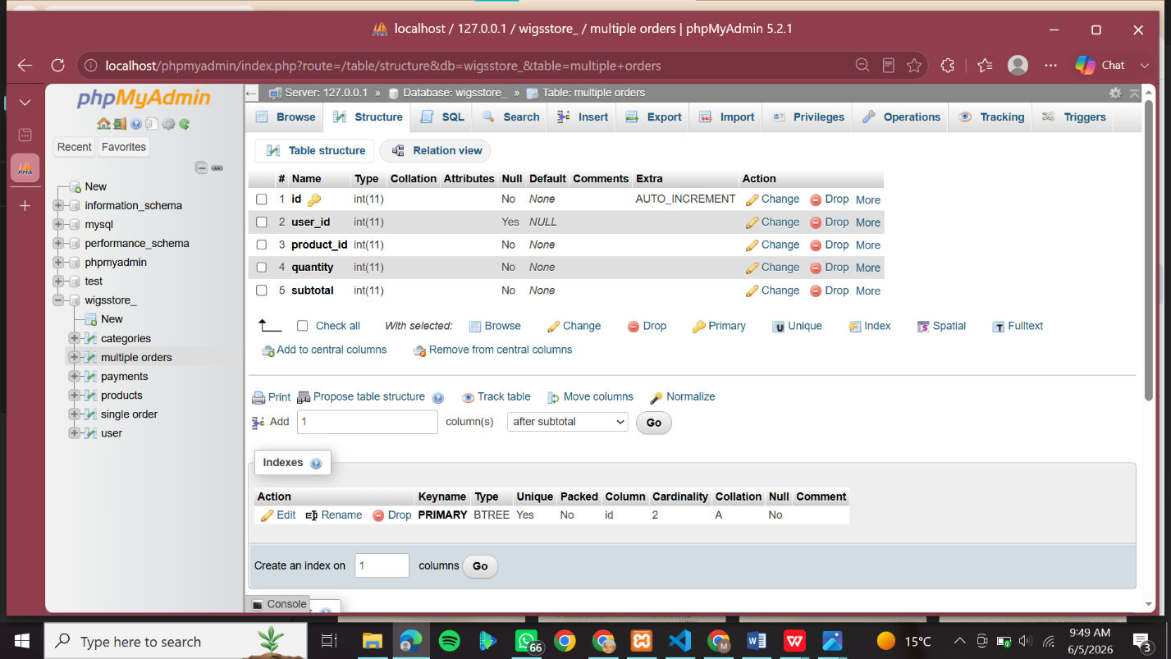

CRUD OPERATION SCREENSHOT Fig 3: Server-Side CRUD Query Implementations for Record Handling
This code snippet tracks our backend repository running structural queries to systematically create, fetch, or modify data rows based on user actions.
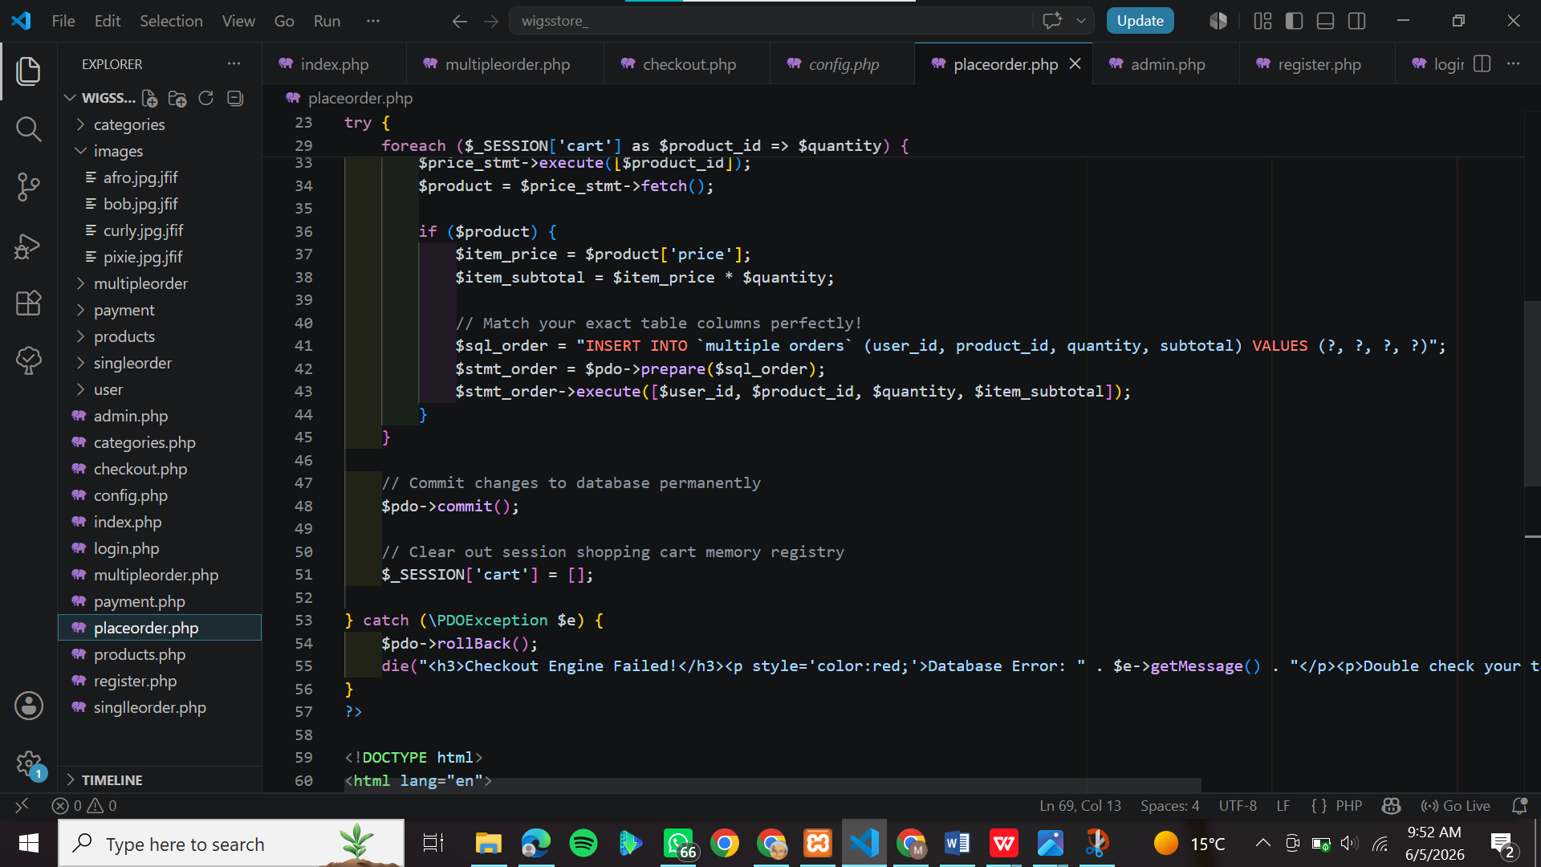

DATABASE CODES Fig 4: Session configuration setup, initializing core state variables.
This code snippet highlights the entry point of our backend file architecture, establishing an active server-side session allocation layer to track authenticated client accounts globally.
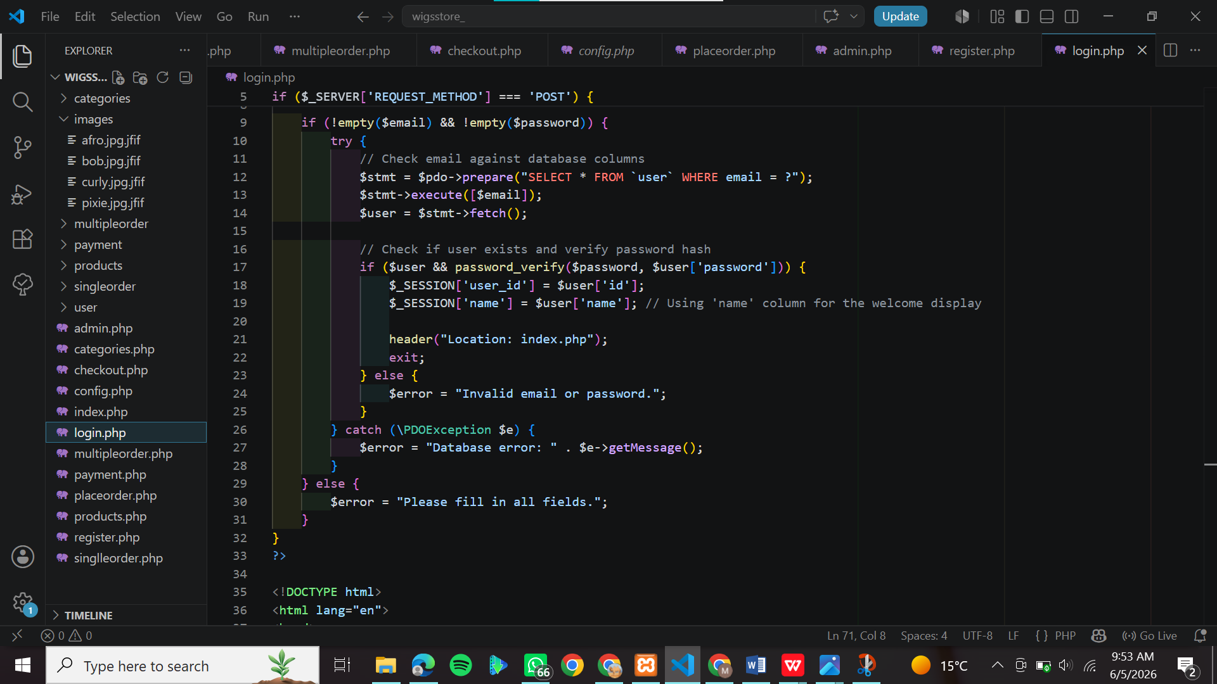

SQL QUERYCODES Fig5: Session configuration setup initializing core state variables.
This code snippet highlights the entry point of our backend file architecture, establishing an active server-side session allocation layer to track authenticated client accounts globally.
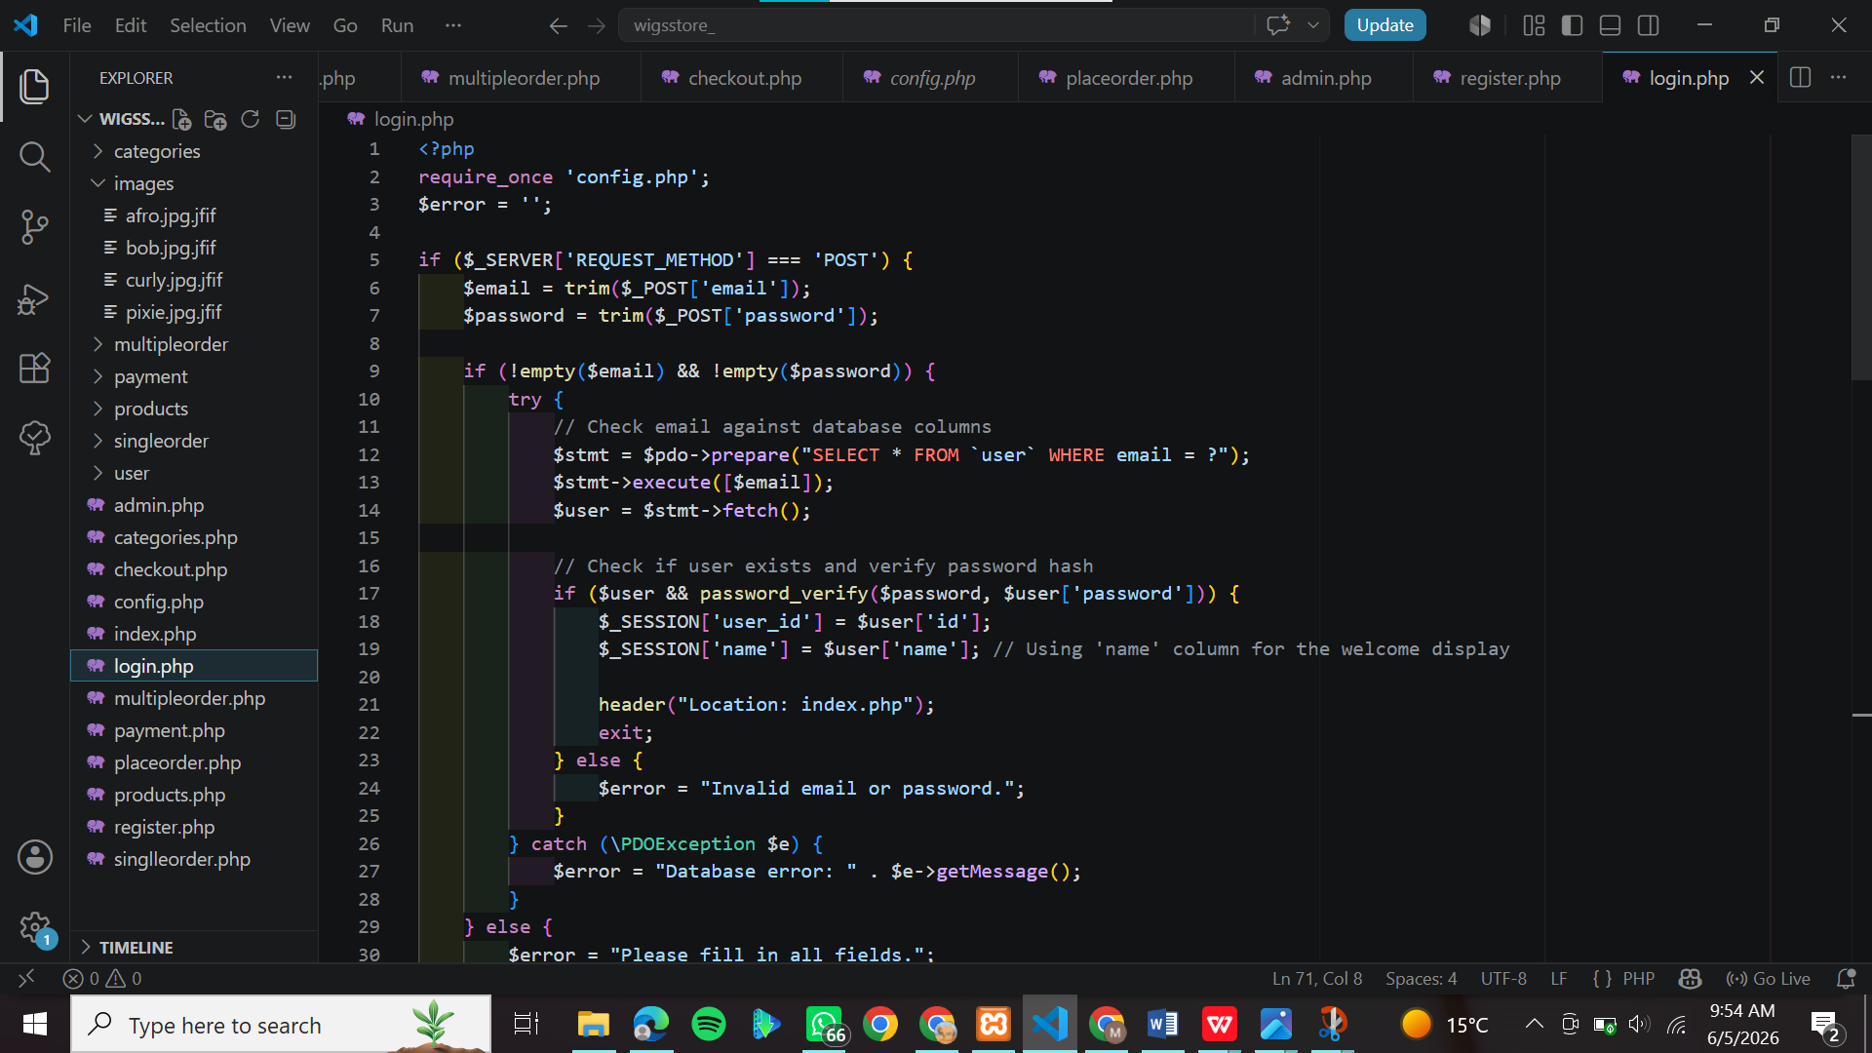

STUDENT REFLECTION
I connected my PHP code to the MySQL database tables to make the wig store run dynamically. This allows the system to fetch and display product items and verify user login details directly from the database. I also exported my Week5db.sql files and saved separate weekly folder backups to ensure my project code remains completely secure and organized.

GITHUB VERSION CONTROL

Project execution history tracking points are registered inside GitHub.
This interface capture displays our active version control ledger matrix, providing concrete evidence of incremental project saving milestones and continuous development logs.

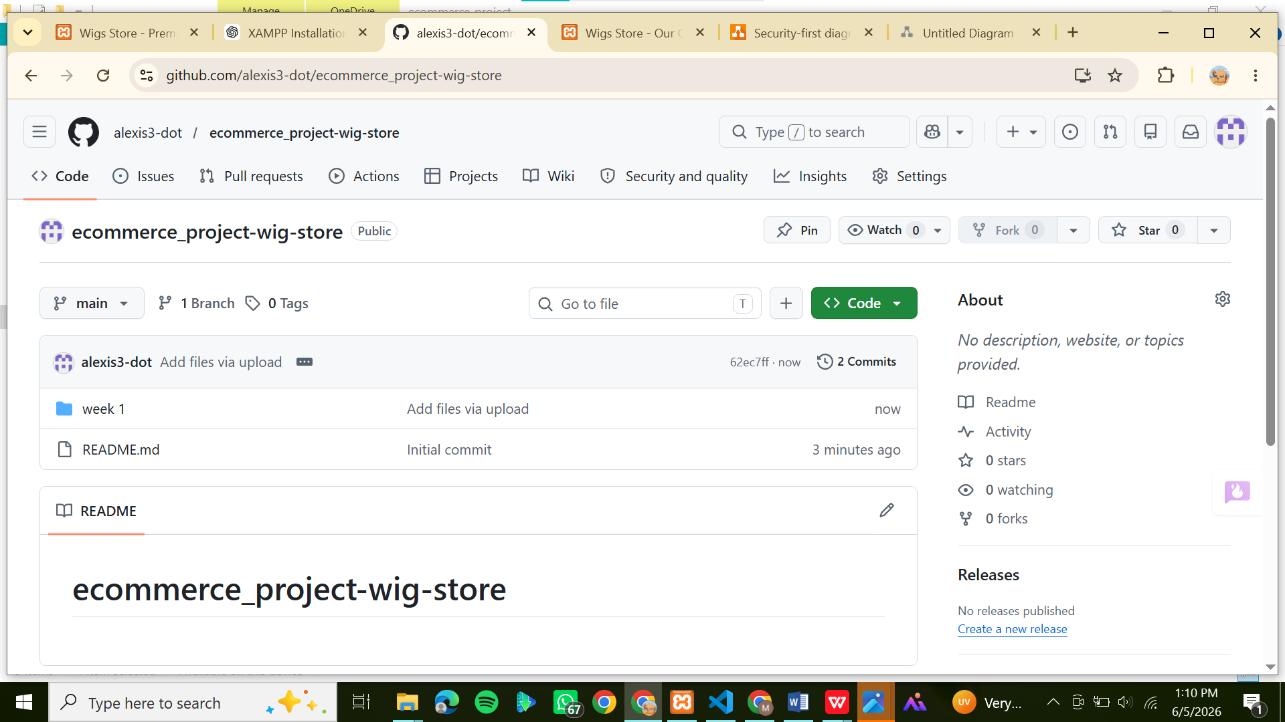

Figure 1: Week 1 File on GitHub
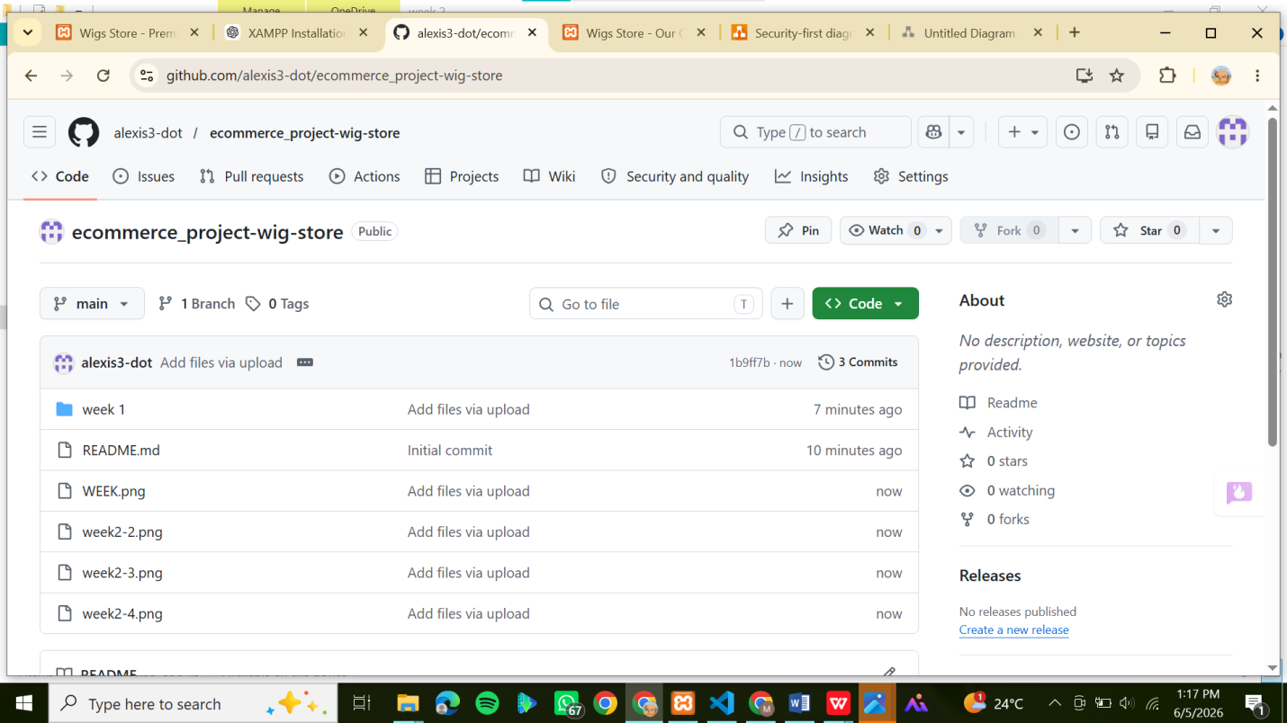

Figure 2:Week 2 Files on GitHub

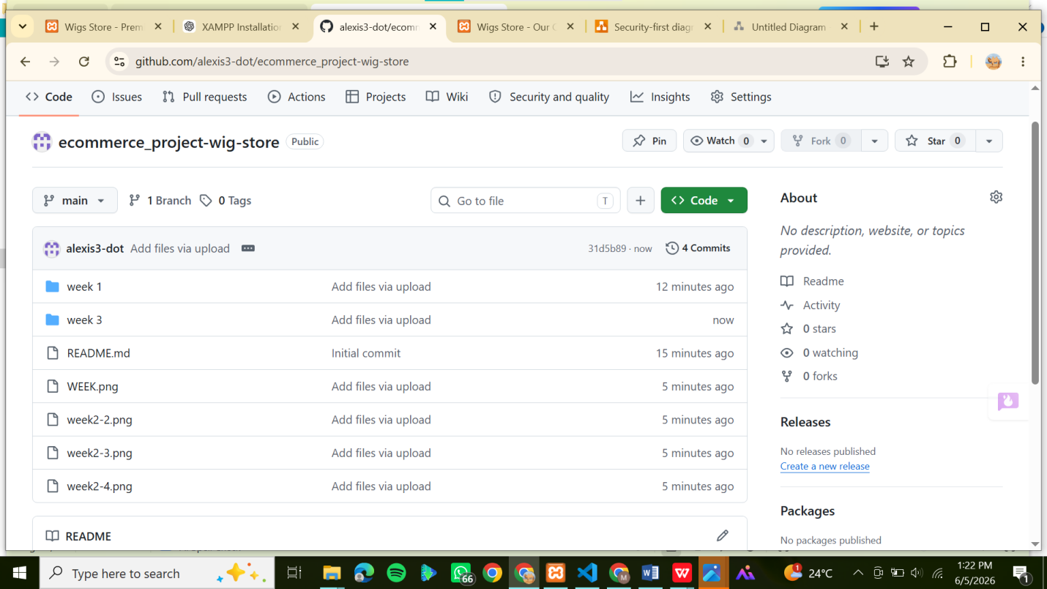

Figure 3: Week 3 File on GitHub

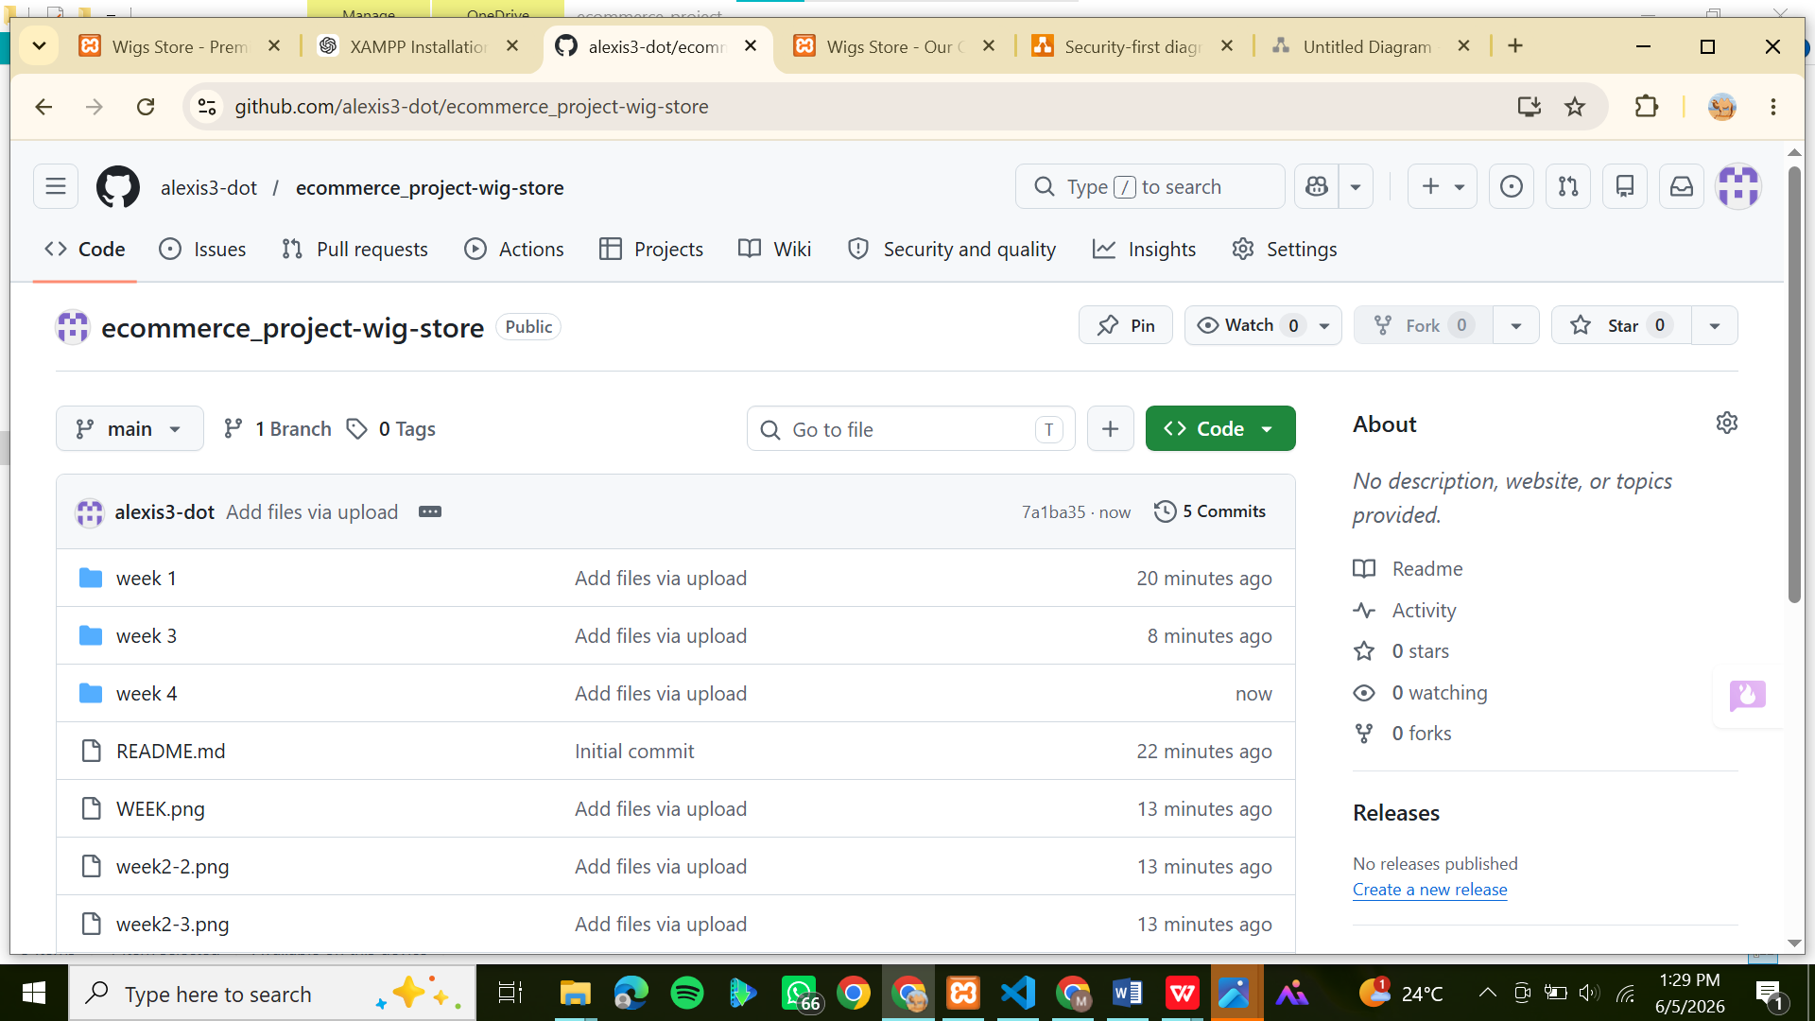

Figure 4: Week 4 File on GitHub

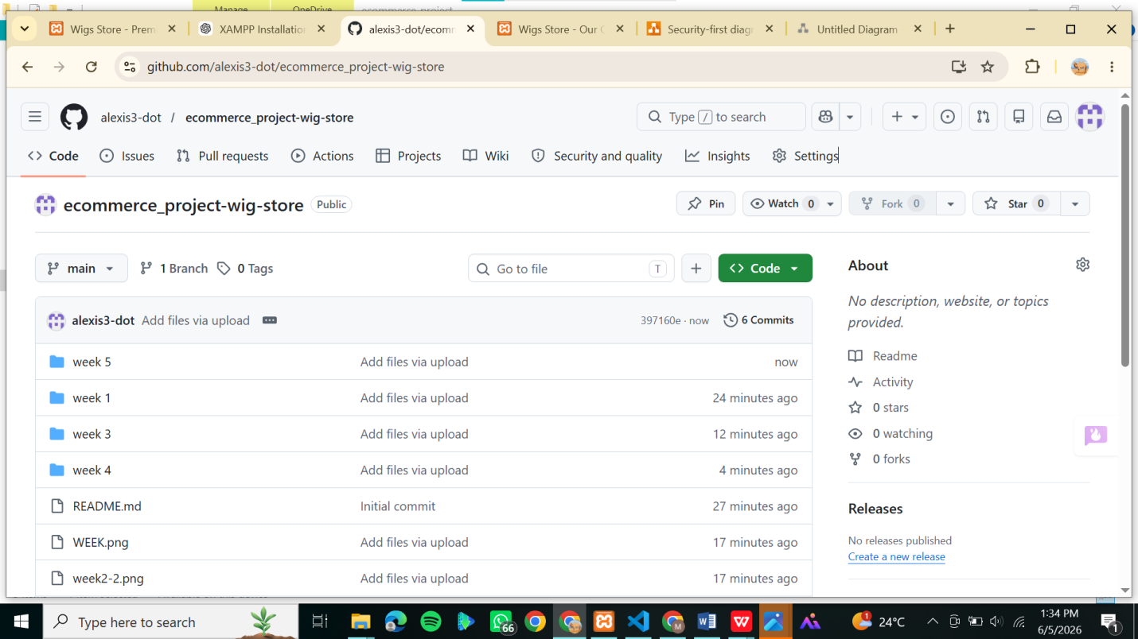

Figure 5:Week 5 File on GitHub

